**A 3D Pacman Game Approach by Team 6**

*Brief Specification, Design, and User Manual*

COMP 371 Fall 2011

Joel Daignault (joel.daignault@gmail.com)

Yu-Shang Lin (daniel.lin13@gmail.com)

Cristian Asenjo (apu2009@gmail.com)

Eric Chan (er_cha@cs.concordia.ca)

## User Manual

Player Control:

i, I – Move Pacman up

j, J – Move pacman left

k, K – Move Pacman down

l, L – Move Pacman right

Miscellaneous:

h, H - Brings up a help menu describing all the keystrokes

r, R - Resets all camera viewing parameters (position, orientation)

p, P - Cycle through smooth shading/flat shading/wireframe mode

F - Enable full screen

f - Leave full screen

G - Restart On Map 1 'pacman.pgm'

g - Restart On Map 2 'pacman2.pgm'

b, B - Toggle on/off Ambient Light

n, N - Toggle on/off Texturing

comma(,) - Toggle Pacman Texture

Camera Navigation:

0 - Switch to Free Camera

1 - Switch to Pac Man Camera

2 – 5 - Switch to Ghost 1 - 4 Camera

6 – 9 Switch to Light 1- 4 Camera

Free Camera Movement:

Move Mouse - Adjust Yaw/Pitch of camera

q, Q - Modify Roll of camera counter-clockwise (barrel roll left)

e, E - Modify Roll of camera clockwise (barrel roll right)

w, W - Move camera forward

s, S - Move camera backward

a, A - Move camera left

d, D - Move camera right

[, ] - Switch to World rotator camera and move either left or right

Light Control:

z, Z - Toggle on/off Light 1

x, X - Toggle on/off Light 2

c, C - Toggle on/off Light 3

v, V - Toggle on/off Light 4

t - Toggle on all Lights

T - Toggle off all Lights

## Design

### Procedural Modeling

Pacman was drawn using GL_TRIANGLES. We use Sin and Cos to make the circular body. The inside of the mouth is drawn separately. The application uses Sin and Cos arithmetic operations to animate Pacman’s mouth. The angle of the opening of Pacman’s mouth is continually altered based on the results of the mathematical operations. In order to maintain the traditional attributes of Pacman, we kept his color as a vibrant yellow; additionally, we decided to not model any eyes on Pacman.

Each ghost is drawn with a gluSphere for head, gluCylinder for body and gluCylinder with a 0 base for feet. The eyes are made with gluSphere for the iris and for the pupil. Again, we elected to stick with tradition by assigning the ghosts the colors they’ve maintained in past generations: Blinky is red, Pinky is pink, Inky is blue and Clyde is orange. We have also added a transparent look on the ghosts to give them a hollow feel.

The walls are drawn using a special function that we made called scubes. It draws quads to make rectangle walls on the area that we want. Additionally, the tiles use the same scube method. The pellets are made using gluSphere. The regular pellets are of size 2 and white while the power pellets are of size 8 and yellow so that they can be easily distinguished.

Every texture that was used was selected based on the requirements set forth from PA3. The textures on Pacman himself were created by us using Gimp. The texture of the floor tiles, our team number, the walls, the lamppost, and the ghosts were found externally, and cited in the References section.

### Software Architecture

We used an Object Oriented software architecture approach to implement our Pacman application. We based all of our game objects off a generic Entity object, and expanded their behaviors and attributes using inheritance. We manage the objects using Handler classes to iterate through the various Entities and perform their logic as required.

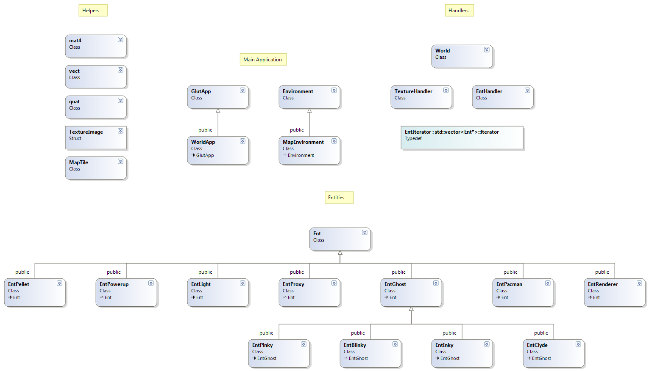

## Code Documentation

All the code that we have used was created from scratch. We have not taken any code from any of the reference projects provided in the project description resources.

## Extra Features

-Pacman works on both Windows and Mac OSX

## Screenshots

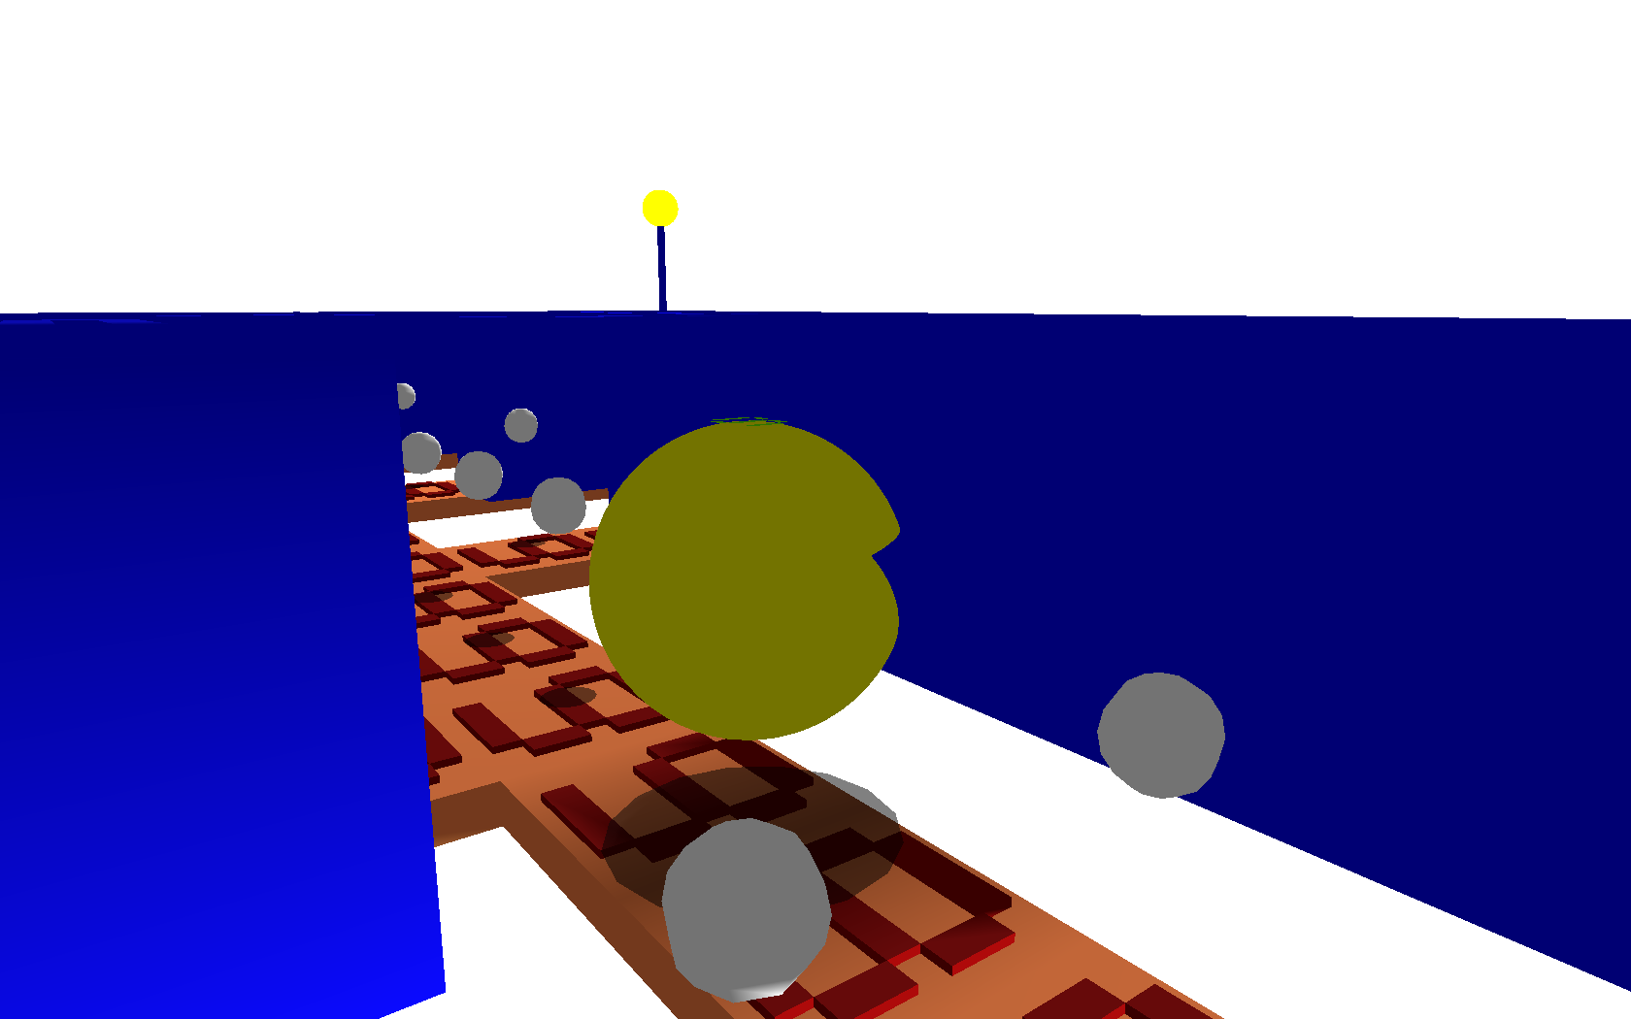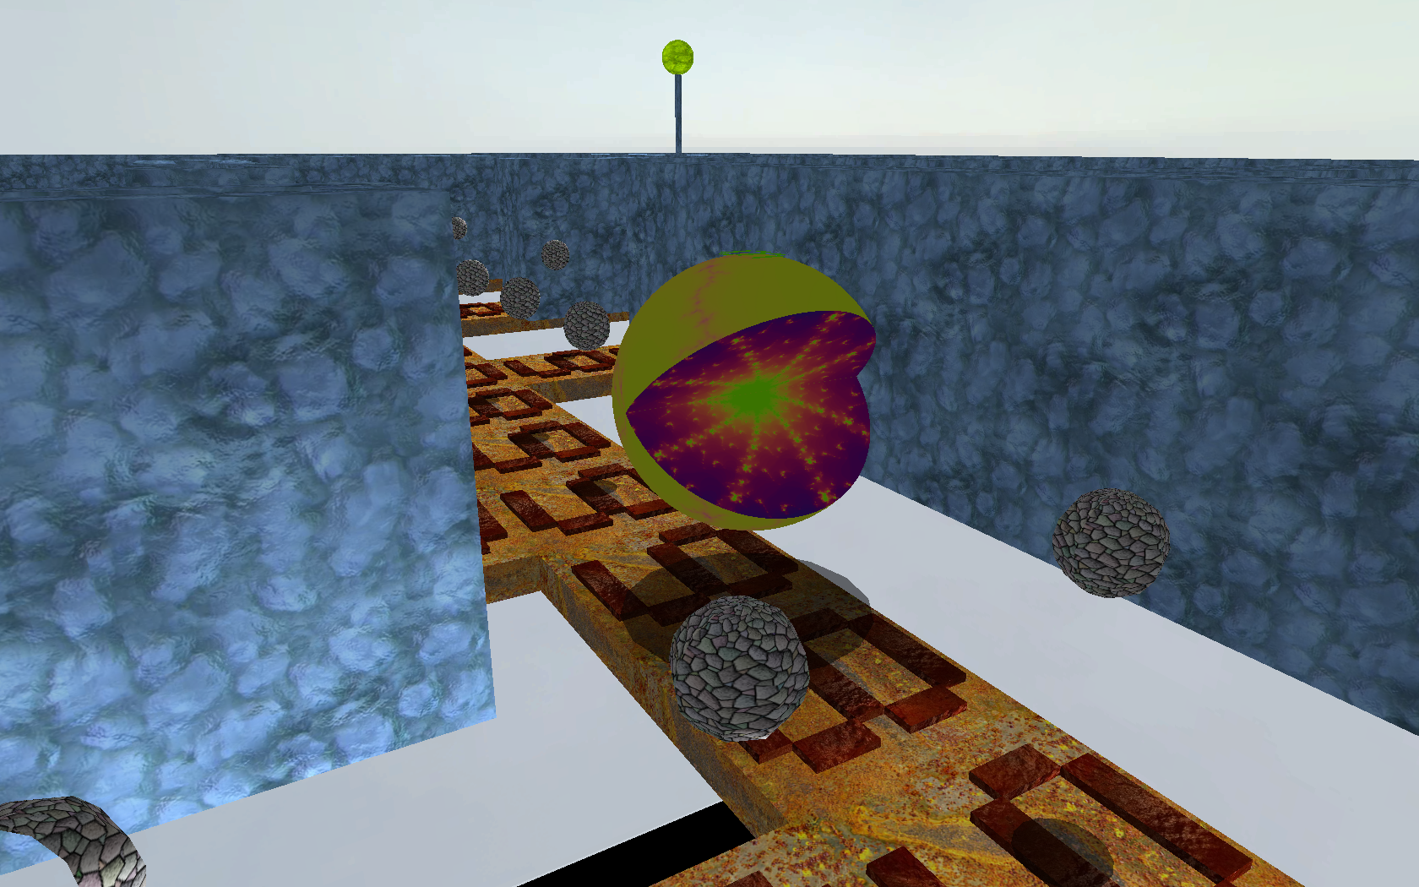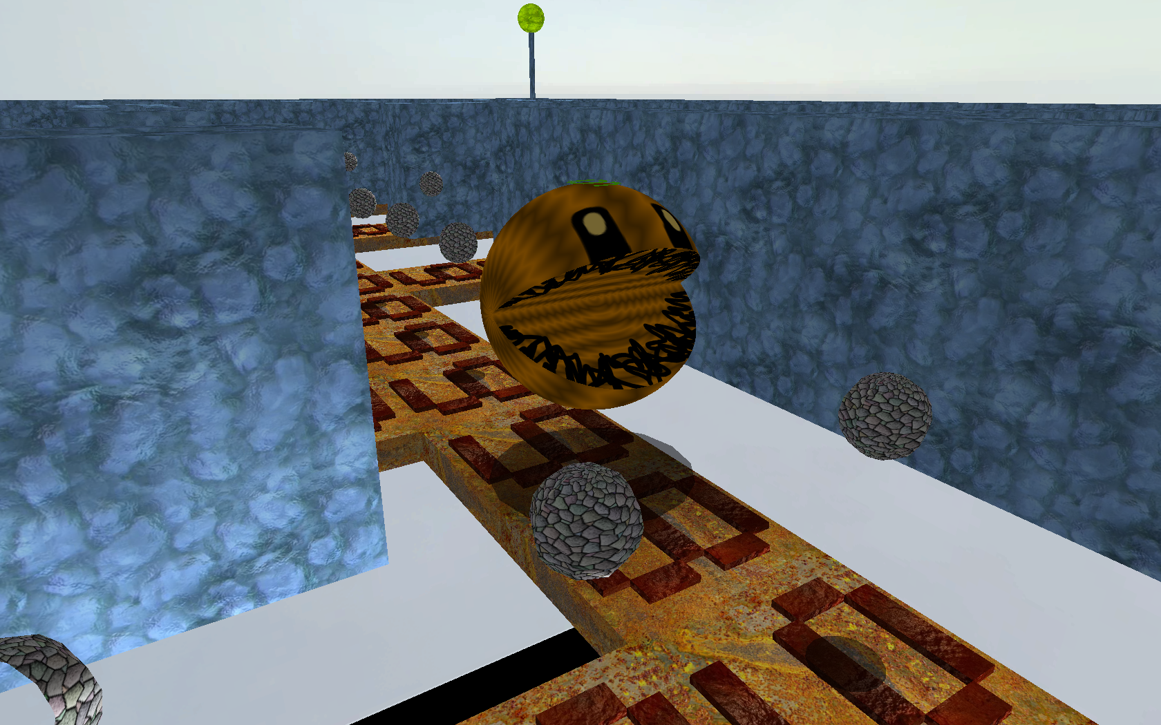

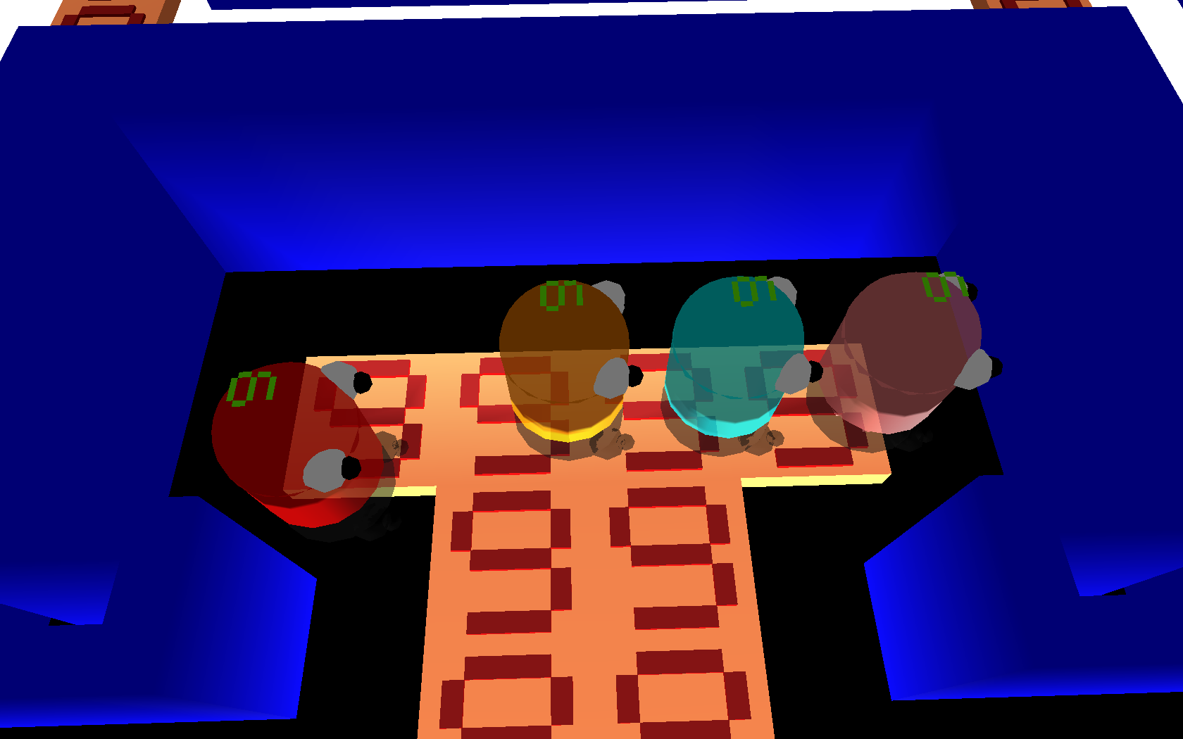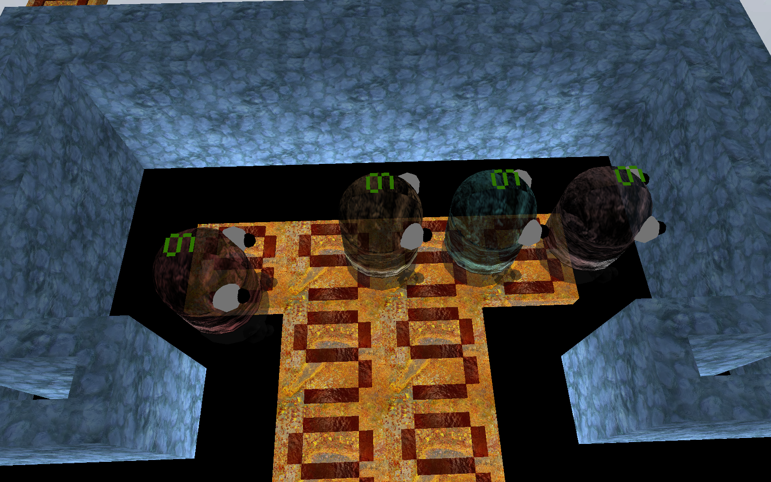

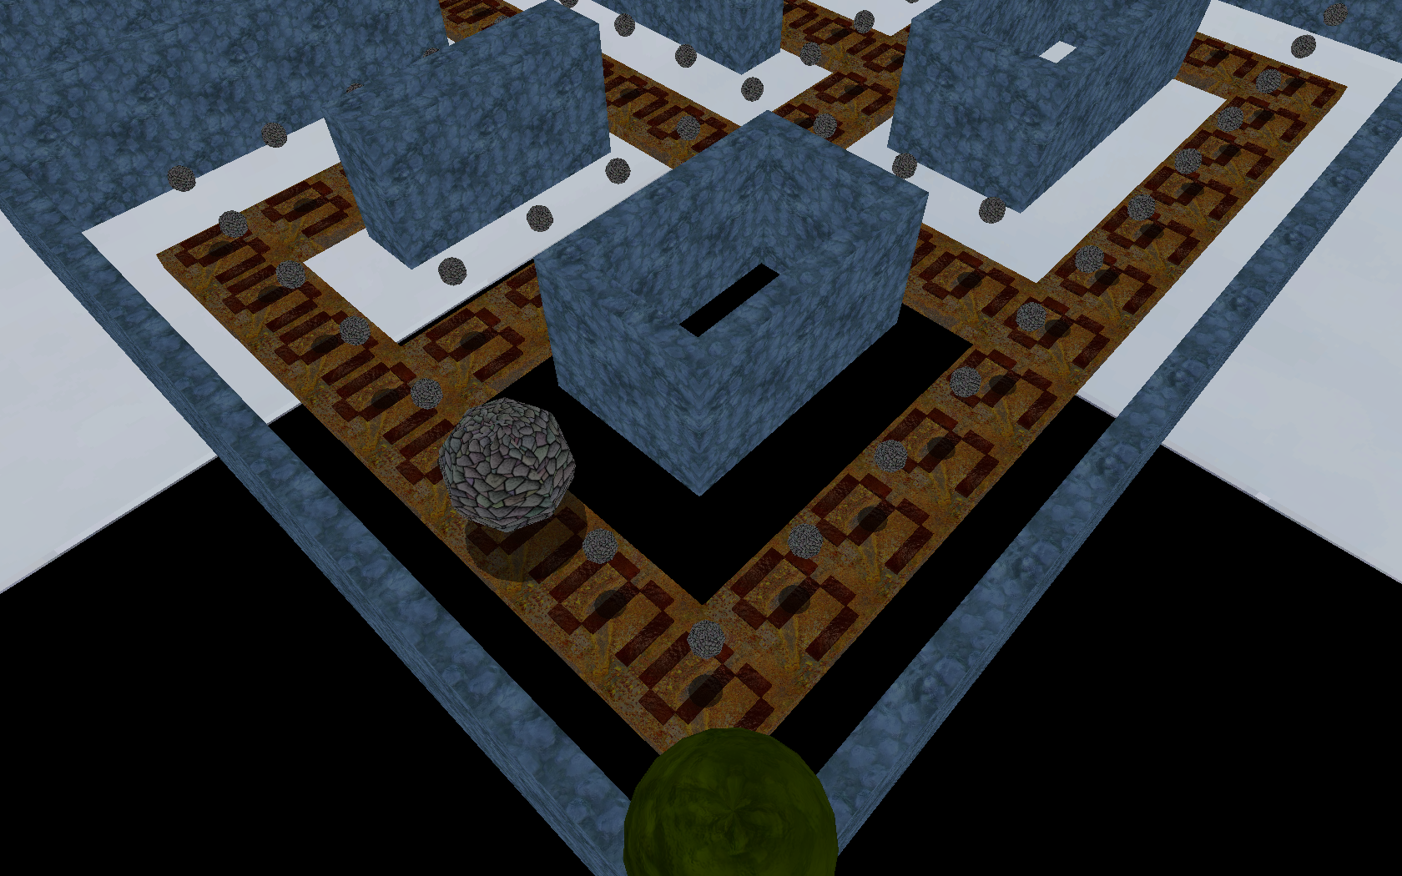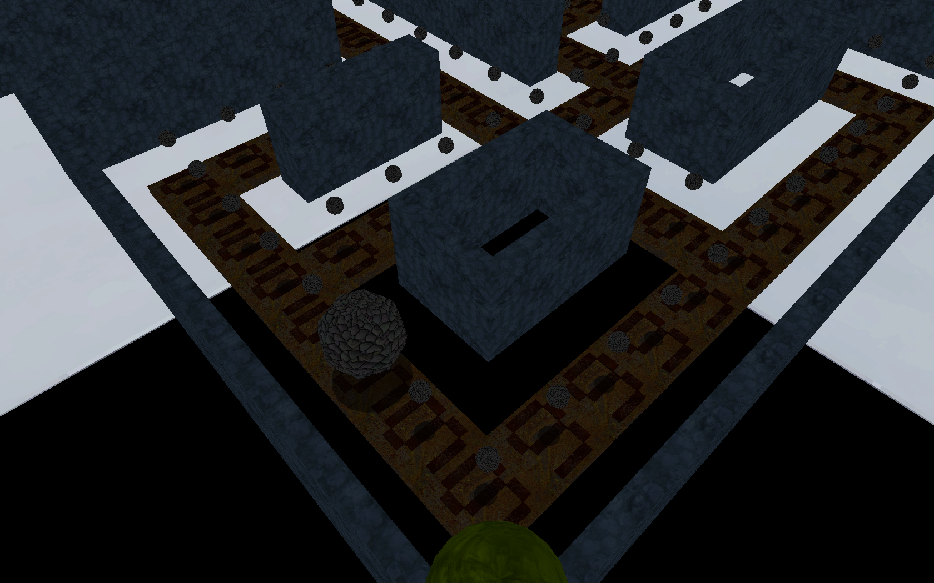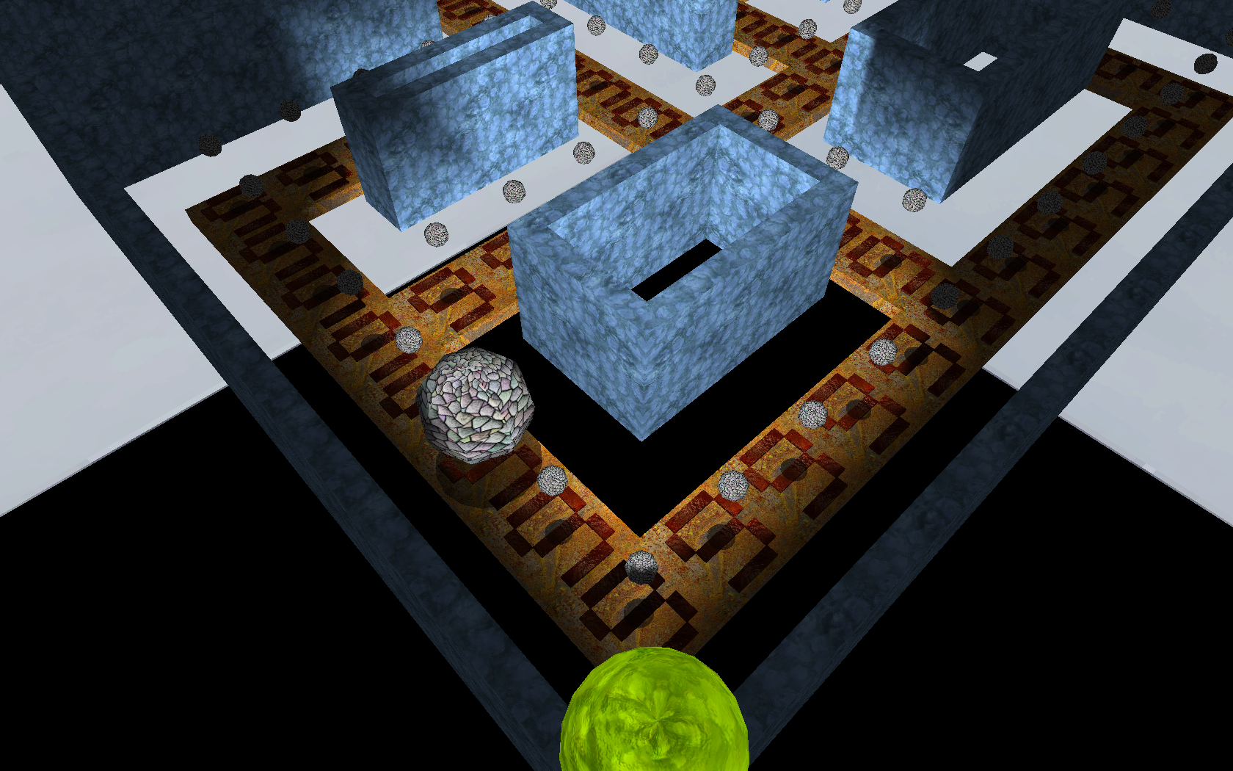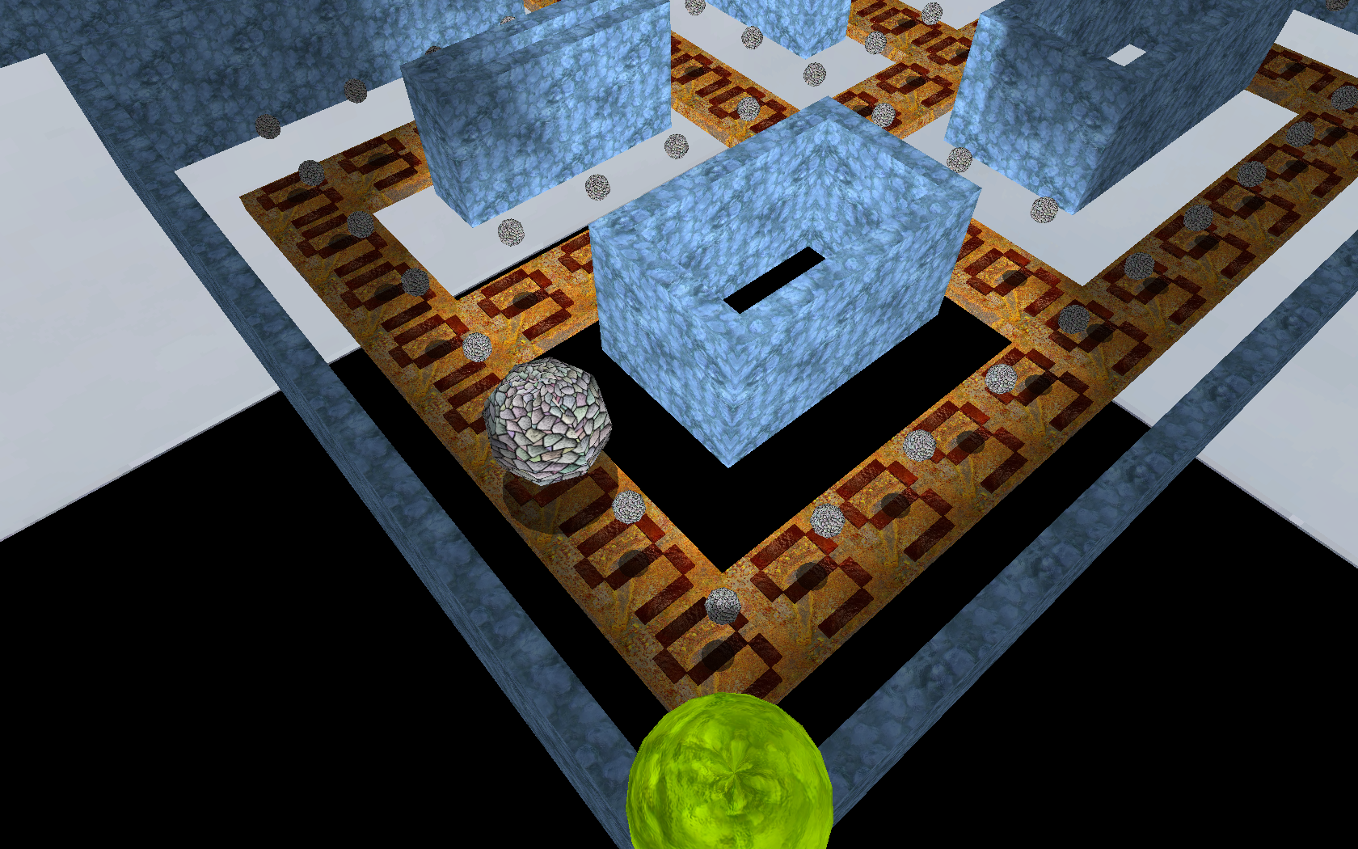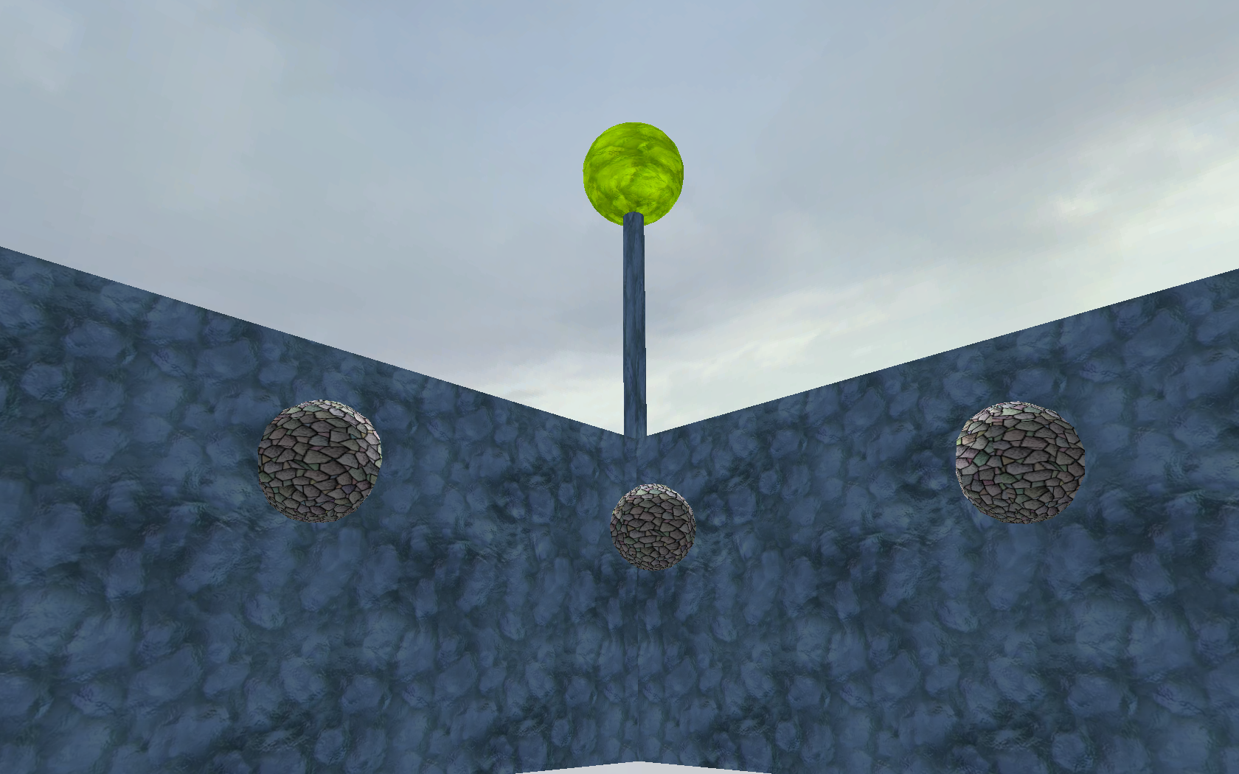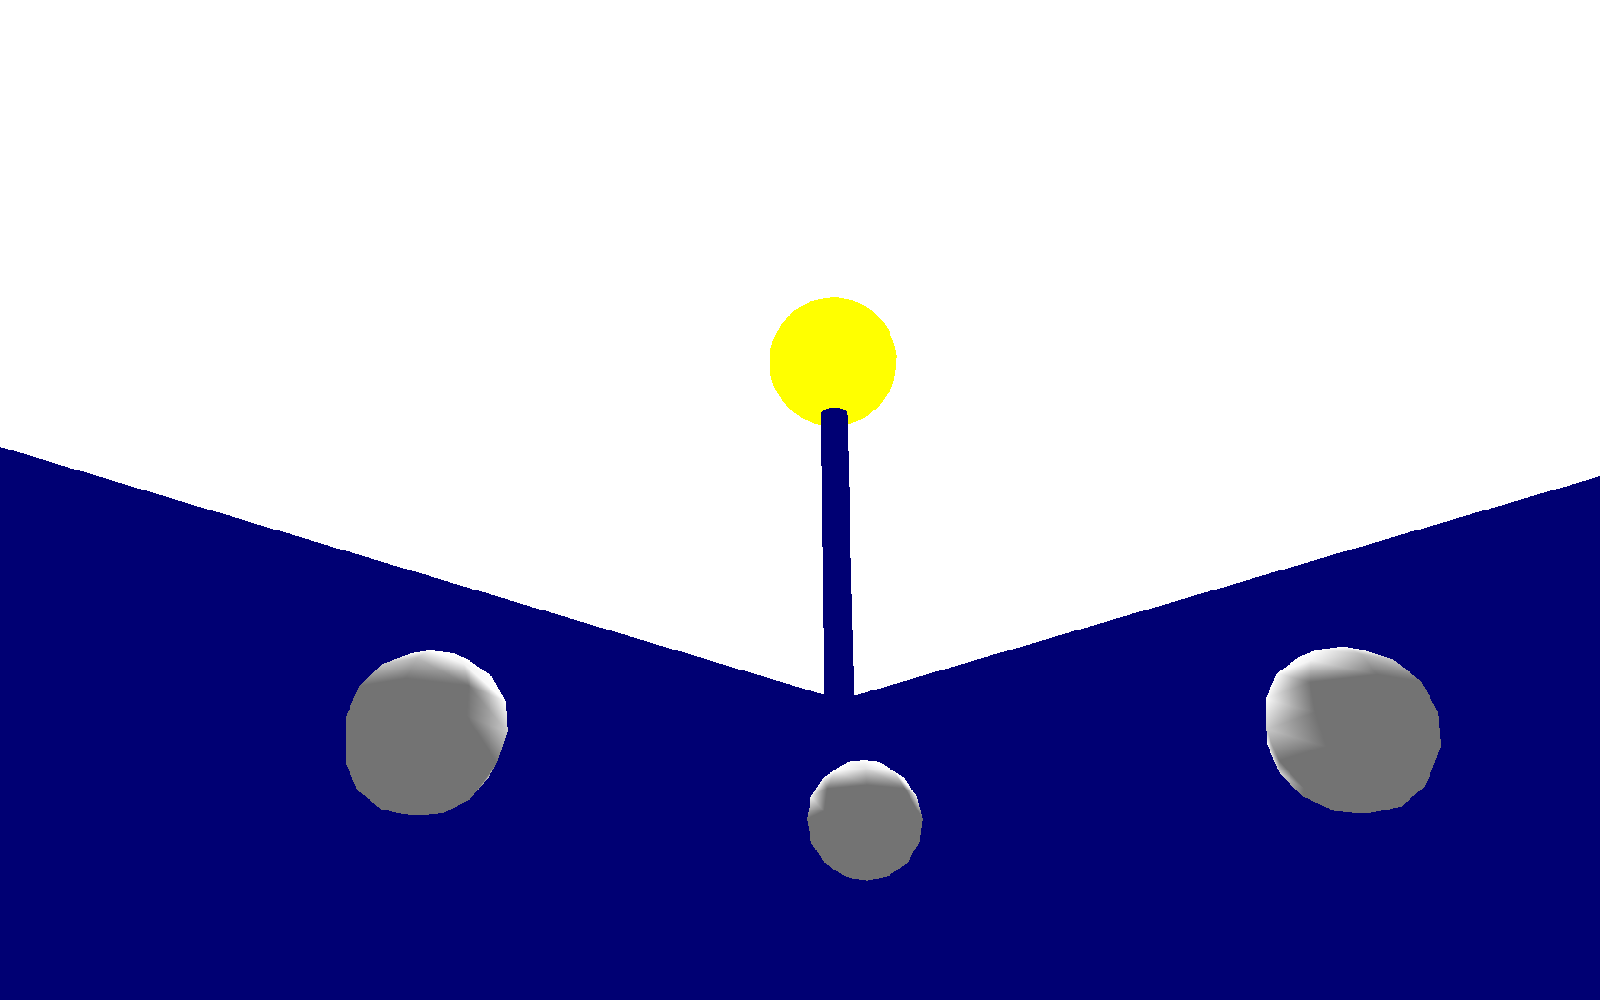

## References

Textures for the floor tiles, our team number, the walls, and the lamppost:

<http://forums.epicgames.com/threads/601110-Shade-s-Liquid-Texture-Samples-%28Slime-tar-oil-blood-water-textures-and-more%29?s=3bd6e39db474fde2fff3b98f57535c53>

Textures for the ghosts:

<http://www.designfreebies.org/design-tutorials/photoshop-tutorials/halloween-graphics-collection-treat-free-vector-cliparts-and-icons-fonts-photoshop-brushes-and-more/>

Textures for the skybox taken from the Source SDK and Half Life 2.

Original Pacman map:

<http://images.pictureshunt.com/pics/p/pacman_game-1973.gif>